Title: Data Security Approach on Cyber Crime with Web Vulnerability

Introduction: -
Investing in cyber-threat intelligence is an important first step in understanding where high-risk vulnerabilities exist in an organisation. These are likely the same areas being targeted by mass distributed hacking platforms, and shoring up their defences can stop low-risk, high-reward threat actors before they have a chance to gain a foothold. Here the cybercrime underground has a highly professional business model that supports its own underground economy. This business model, known as CaaS(Crimeware-as-a-Service) is “a business model used in the underground market where illegal services are provided to help underground buyers conduct cybercrimes, such as attacks, infections, and money laundering in an automated manner,”. Thus, CaaS is referred to as a do-it-for-me service, unlike crimeware which is a do-it-yourself product. Because CaaS is designed for novices, its customers do not need to run a hacking server or have high-level hacking skills.
The “absence of capable guardians against crime” is due to organizations failing to take preventive measures against cybercrime. Consequently, the CaaS business model can involve the following roles: writing a hacking program, performing an attack, commissioning an attack, providing an attack server (infrastructure), and laundering the proceeds. Crimeware marketplaces have three key elements, namely actors (e.g., coders, operators, or buyers), value chains, and modes of operation (e.g., CaaS, pay-per-install, crimeware toolkits, brokerage, or supplying data). Periodic monitoring and analysis of the content of cybercrime marketplaces could help predict future cyber threats.

Scope and Methodology:-
Implementation is one of the critical stages of the project; it is nothing but a change of working system from the theoretical system design

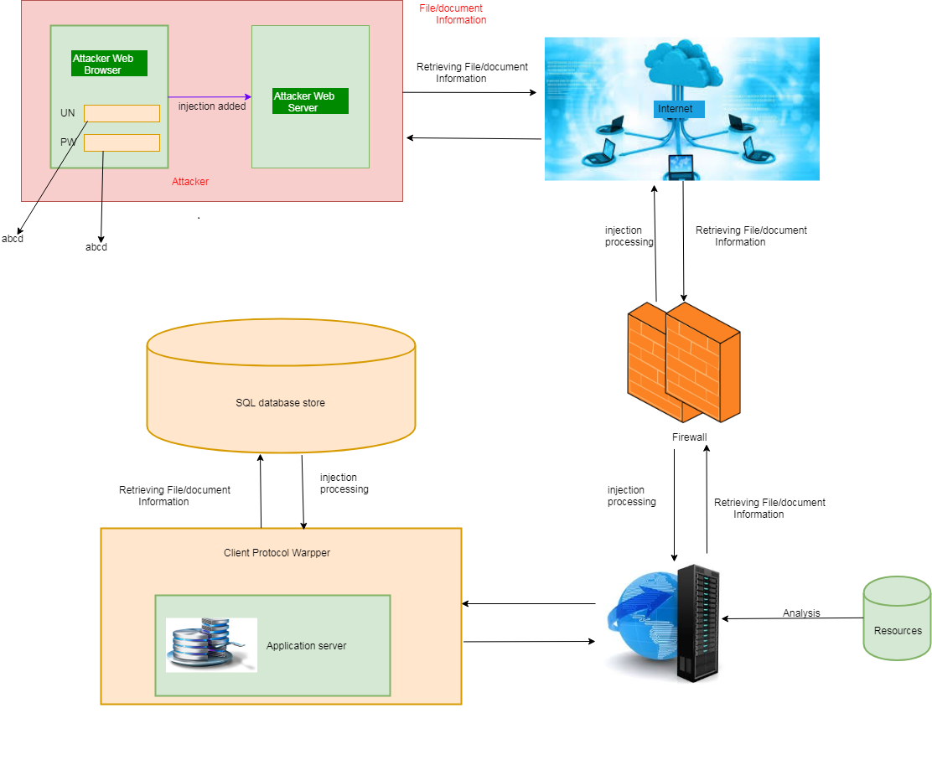

The attacker injects payload in website database by submitting a vulnerable form with some malicious JavaScript. The victim browser page loads with the payload that has been injected as a part of the HTML body. The script will send the victims cookie to the attacker’s server. The attacker will now extract the victim’s cookie when the request arrives to the server. Here Java Script allows the attacker to use malicious scripts to hack important details. The victim will not be directly targeted by the attacker. Instead he delivers malicious java scripts while the user visits the website. Here when the attacker injects the malicious java scripts via login page. He will be directly allowed to access the database of our website where he can get all important information he needed.Finally the user can use the victim’s stolen cookie.
IDENTIFYING SOURCES:-
These proposed sets of definitions for different types of CaaS the most common account hacking methods are phishing and brute force attacks. With an emphasis on selling this as a service, we define an account hacking service as a service that offers to gain unauthorized access to a target’s account by obtaining account information (e.g., username and password) or extra security information (e.g., security questions and answers).

Phishing Services
The term “phishing” is a portmanteau of “password” and “fishing,” where the latter refers to catching fish using bait or a lure. We thus define a phishing service as a service that hacks accounts by pretending to be a reliable source, such as a bank or card service.

Brute Force Attack Services:
an attacker may try to log in using one of the system’s default usernames (e.g., “root” or “admin”) by systematically trying all possible passwords. We thus define a brute force attack service as a service that hacks accounts by trying all possible passwords

DDoS Attack Services: In the research literature, a DDoS attack is defined as “an attack which makes resources unavailable to its legitimate users,”. In the business practice literature, it is defined as “an attack involving an enormous number of spurious requests from a large number of computers worldwide that flood a target server,” We thus define DDoS attack service as a service that makes one target service unavailable by flooding it with traffic from multiple compromised sources.

Spamming Services: Over the last decade, spamming has been defined in a variety of ways in the literature. The academic literature defines spam as “unsolicited and unwanted e-mail from a stranger that is sent in bulk to large mailing lists, usually with some commercial objective,”

Crypting Services: Crypter encrypt programs or source code to avoid detection and tracking and thus bypass anti-virus software . Like other hacking services, encryption is sold as a service because crypters require a certain level of skill to use. The goal of such a service is to neutralize the preventive measures put in place by organizations and anti-virus software, preventing hacking programs from being caught or allowing them to be left behind to collect information. We define an crypting service as a service that encrypts malicious code by using a crypter to bypass anti-virus software

In Crimeware -(drive-by download, botnets, exploits, ransomware, rootkits, Trojans, crypters, and proxies) have applied several modern techniques, such as machine learning, key phrase extraction, and natural language processing, in this area, thereby encouraging future research to be more systematic and empirical. In addition, our results suggest that combining natural language processing and machine learning approaches is a suitable way to study closed communities whose members frequently used. As a result, governments should, for example, strengthen their ability to protect their citizens in online virtual environments by enhancing their immediate responses to threats such as cyberespionage and cyberterrorism. This issue therefore has profound implications in terms of the need for a global cyber defense to maintain a cyber-safe environment
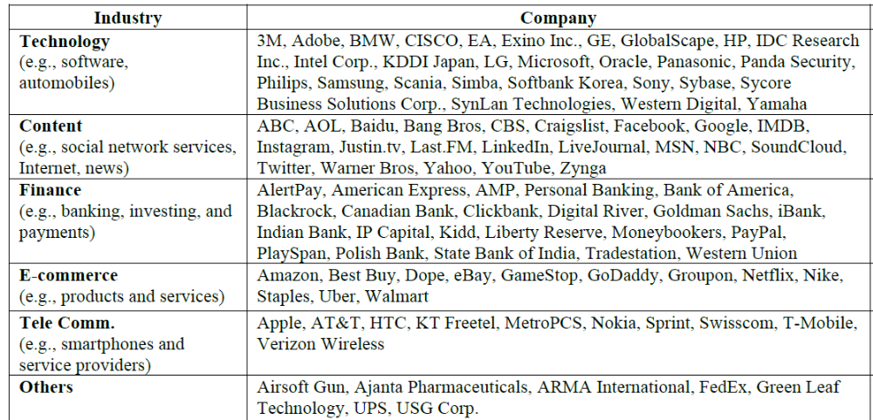

FUTURE WORK:
Although our study has made several significant findings, it nevertheless has several limitations that will need to be addressed in future studies. These will be able to add more analysis and significant further insights. First, we only collected data from the largest hacking community and did not consider other hacking communities. Future studies will therefore need to generalize our findings by investigating a wider range of hacking communities. Second, this study has focused on the CaaS and crimeware available in the cybercrime underground, but much in-depth analysis remains to be done on the configurations of cybercrime networks. Future research could cluster keywords and threats by industry to provide a deeper understanding of the potential vulnerabilities, and it could attempt to discover the network effects involved or the leaders of the cybercrime underground.

